**NUMERICAL ASSIGNMENT**

Q1: Draw the Plain Graph of Figure (1)

Q2: Draw the oriented graph of Figure (2)

Q3: Draw the oriented graph of power line diagram of Figure (3)

Q4: Draw the different forms of a Tree from a given circuit in Figure (4)

Q5: Draw the Tree of a given graph, and calculate the: (1) Twigs (2) Links (3) Nodes from the Tree? From Figure (5)

Q6: Calculate the number of Chords and also draw the cotree in the given circuit figure (6)

Q7: From the Tree and Cotree Figure below, calculate the number of elements (e), number of nodes (n), number of branches (b), and number of links (l) in Figure (7).

Q8: Find the Bus Incidence matrix of the graph as shown in Figure (8)

Q9: For the Circuit as shown inf Figure (9) write the Tie matrix.

Q10: Find the Ybus matrix using Singular Transformation method and also verify by Inspection Method, as shown in Figure (10).

Q11: Find the Bus Admittance matrix of Figure (11)

Q12: Find the Bus Impedance matrix of Figure (12), all values in impedances.

Q13: Apply Kron method to calculate the YNEW BUS, all values in admittance as shown in Figure (13).

Q14: Calculate the Line currents in three wire Y-Y system of Figure (14)

Q15: Apply Jacobian Method to solve the system of equations

5X1 – X2 + 2X3 = 12

3X1 + 8X2 – 2X3 = -25

X1 + X2 + 4X3 = 6

Q16: Find the Fault Current from the network as shown in Figure (15)

Q17: Apply Crouts Method to solve the system of equations

X + 2Y + 3Z = 14

2X + 5Y + 2Z = 18

3X + 2Y + 5Z = 22

Q18: Apply Cholskey Method to solve the system of equations

3X1 + 2X2 + 4X3 = 9

2X1 + 5X2 + X3 = 8

4X1 + X2 + 7X3 = 12

Q19: Apply the Gauss Sedial Method on the network as shown in Figure (16)

Q20: Apply NR Method to solve following equations

J1(X1, X2, μ) = 4μX2 Sin (X1) + 0.60

J2(X1, X2, μ) = 4X2 – 4μX2 Cos (X1) + 0.30

LIST OF FIGURES

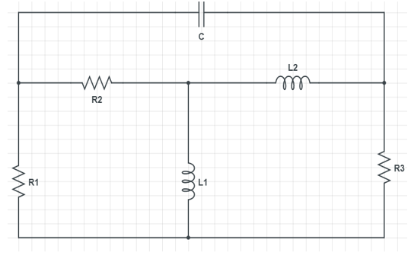

FIGURE (1)

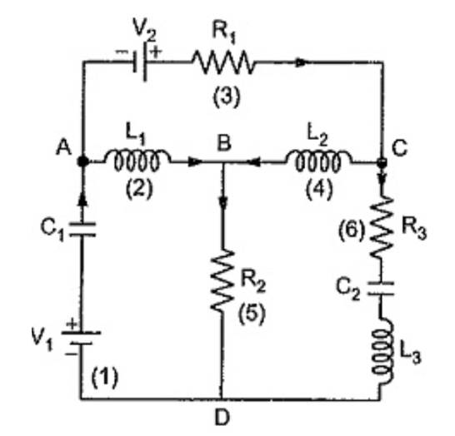

Figure (2)

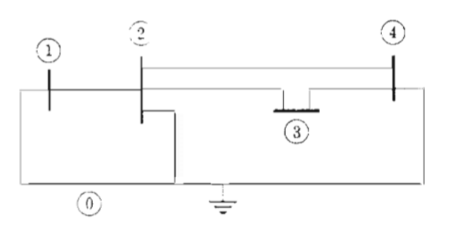

Figure (3)

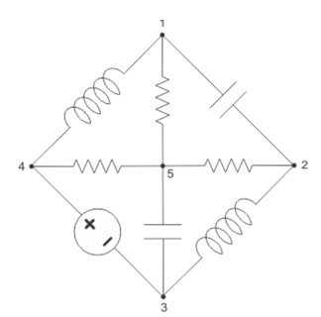

Figure (4)

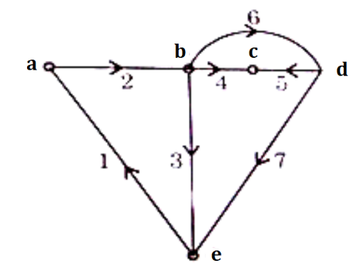

Figure (5)

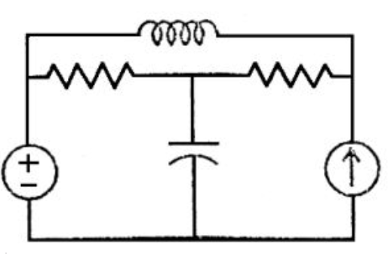

Figure (6)

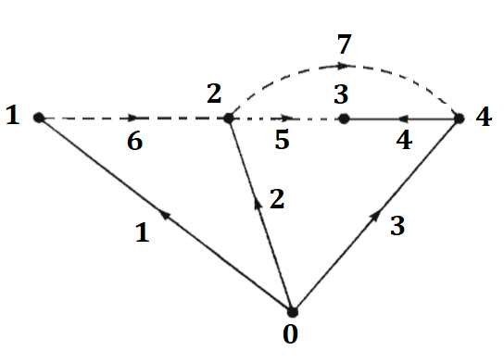

Figure (7)

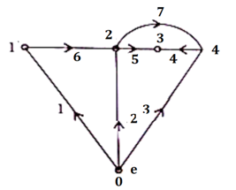

Figure (8)

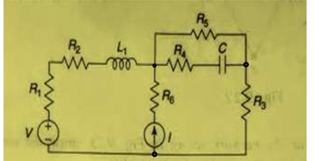

Figure (9)

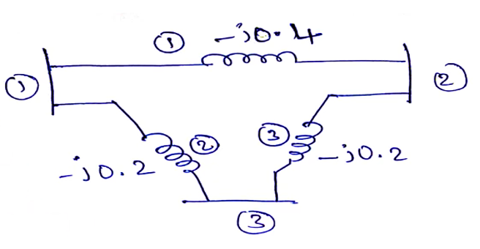

Figure (10)

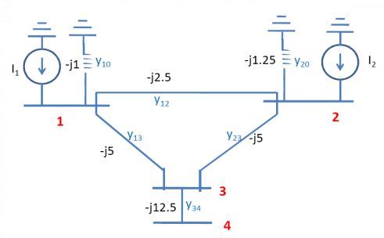

Figure (11)

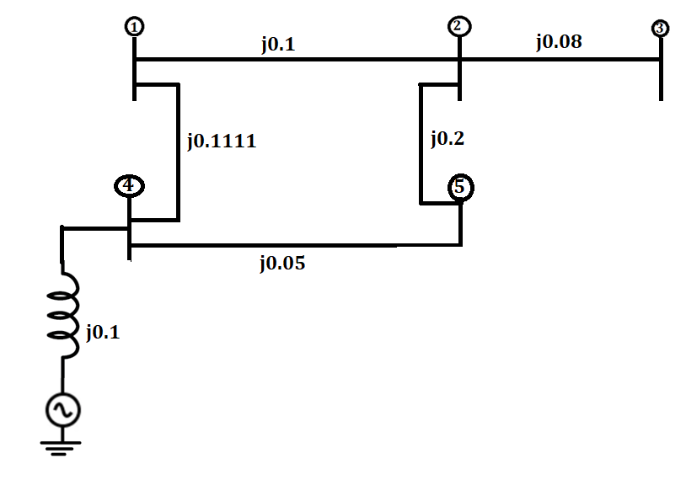

Figure (12)

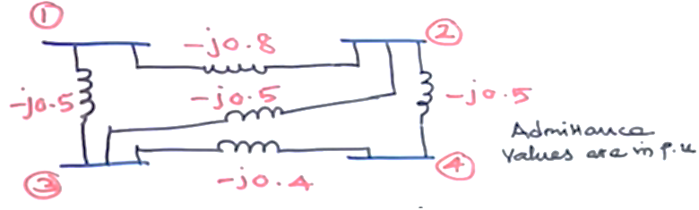

Figure (13)

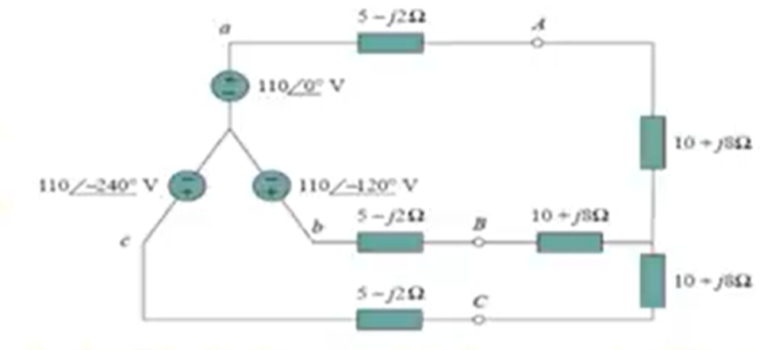

Figure (14)

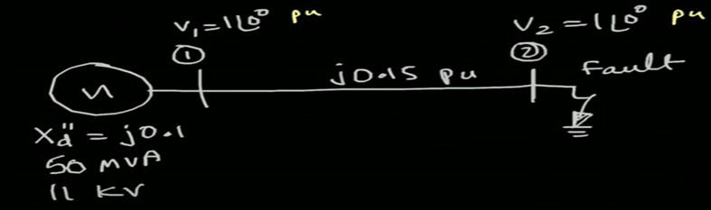

Figure (15)

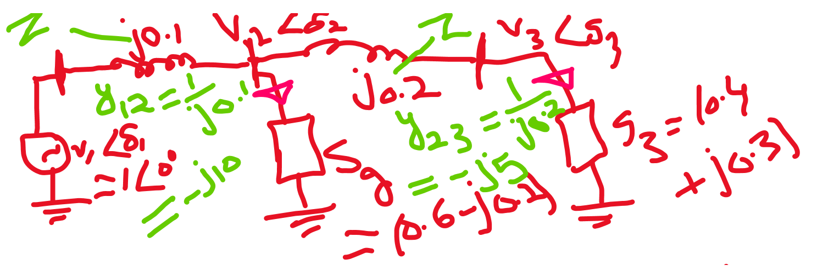

Figure (16)